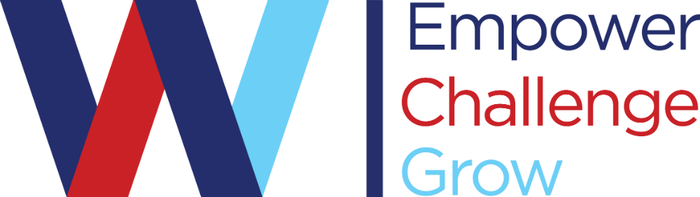

# Course Syllabus

Van Wyck Junior High School

Social Studies

Social Studies 7 Honors

Fall of 2023

## Instructor Information

Instructor: Cole Bender

Room Location: 132

E-mail: cole.bender@wcsdny.org

Extra Help Time: I am available during class, shared periods off and via email after school hours.

## Course Identification

Course Number: D167

Course Name: Grade 7 United States and New York State History- Honors

Course Location: 132

Prerequisites: Placement in the Honors program is by application. The selection process takes place at the end of the third semester of grade 6. Social Studies and English Language Arts (ELA) are blocked for teaming purposes - in order to qualify for Honors, the student must meet the criteria in both Social Studies and ELA. Students are evaluated by their grade 6 teachers in areas such as attendance, attitude, participation, reading, writing, ability to analyze and solve problems, etc

## Course Description/Overview

Areas of Study Include: • The People of the “New World “prior to 1500 and European Contact • European Exploration and Colonization of the Americas • A Nation is Created – the American Revolution and the formation of the United States • Experiments in Government– the Articles of Confederation and the Constitution • Life in the New Nation • Division: the Civil War

### Course Website(s)

[Mr. Bender's website](https://www.wappingersschools.org/Domain/2371)

### Required Course Text

* American Stories

### Course Supplies

* Chromebook

## Course Learning Objectives

In Grades 7 and 8, students will examine the United States and New York State through a historical lens. The two-year sequence is arranged chronologically, beginning with the settlement of North America by Native Americans∗ and ending with an examination of the United States in the 21st century. Although the courses emphasize the skill of chronological reasoning and causation, the courses also integrate the skills and content from geography, politics, economy, and culture into the study of history.

As outlined by the New York State Social Studies Framework, Grade 7 Social Studies is arranged chronologically and incorporates geography as well as economic, social, and political trends. The course content is divided into eight Key Ideas, tracing the human experience in the United States from pre-Columbian times until the Civil War, with a focus on the people, events, and places in New York State as applicable. Throughout the course, teachers should help students see connections across time

Grade 7: Social Studies Practices

A. Gathering, Interpreting and Using Evidence

B. Chronological Reasoning

C. Comparison and Contextualization

D. Geographic Reasoning

E. Economic and Economic Systems

F. Civic Participation

Student outcomes for the social studies curriculum can be found at https://www.engageny.org/resource/new-york-state-k-12-social-studies-framework

**Grading Policy:**

Homework = 1-15 points Classroom Activities= 1-25 points

Quizzes = 10-50 points Tests/Projects = 50-100 points

**SAMPLE GRADE**: HW#1 HW#2 HW#3 Test#1 Quiz #1 Quiz#2 TOTAL

**POINTS WORTH**: 5 5 5 100 50 50 215

**POINTS EARNED**: 5 5 5 85 40 45 185

GRADE = POINTS EARNED (185) / POINTS ASSIGNMENT WORTH (215) X 100 = **86**

Every assignment is given a point value. The student's final grade is determined by **adding up all the points in the assignments** and dividing that number by the total points possible.

## Course Policies

*Classroom Rules:*     
    1.  Show respect for yourself, for others, and for the facilities and equipment.  
    2.  Act in a responsible manner in everything you do.  
    3.  Practice safety in regards to yourself and towards others.  
  
*Students are expected to:*  
    1.  Be a positive influence on others.  
    2.  Follow classroom rules.  
    3.  Come prepared to class daily (Bring Charged Chromebook)  
    4.  Complete assignments by their due dates.  
    5.  Work to the best of your ability.  
    6.  Actively participate in cooperative groups and classroom discussions.

7. Have their cellphones off and away

…..………………………………………………………………………………………………………….

**Tests and Quizzes (Expectations and policies):** Mr. Bender posts a study guide a week before any test or quiz on google classroom. The study guide will consist of a list of topics and essential content/questions to focus on. The study guide is to be completed by the students on their own time. If students have questions about the test or study guide, they are encouraged to ask them during class or via email/google classroom. Students will be prepared for the quiz/test during class, but it is also their responsibility to study for the quiz/test outside of class. **There are no test redoes, test corrections, or extra credit offered.**

-------------------------------------------------------------------------------------------------------------------------------

**Classwork/Homework**

* Classwork/Homework is expected to be turned in on time at all times.
* Deadlines can be renegotiated if you notify me in advance that you are having trouble meeting the established due date.
* Computer/printer problems are NOT valid excuses for failing to meet a deadline
* Late classwork & homework will lose 40% per day. Study guides turned in late will only be worth up to 20%.
* Students are expected to come prepared everyday with a charged chromebook. Coming unprepared to class without a charged chromebook may result in percentage points off.
* Work refused during class may be turned in at a later time for up to 50% credit.
* Classwork and Homework will be posted in google classroom.

**School Counseling**

Wappingers Central School District is committed to advancing the mental health and well-being of its students.  If you or someone you know is feeling overwhelmed, depressed, and/or in need of support, services are available.  For help or to find additional resources, contact the School Counseling Office at (845) 227-1700 visit the [School Counseling website.](https://www.wappingersschools.org/Domain/2619)

## Academic Integrity Rules

*As outline in the Wappinger Central School District Code of Conduct:*

1. **HONOR CODE**

A healthy learning environment can exist only if a commitment is made by all to live in the most ethical way possible. Those who refuse to make this commitment hurt not only themselves but also those in the entire school community.

1. **Cheating**

The District recognizes all policies and procedures required by NYSED for instances of cheating on all New York State Assessments. For class assigned work or local assessments a grade of zero may be given to any student who gives or receives information, including electronically, on any form of a test, quiz, homework, assignment or lab. Any person falsifying a grade or a test or related material, with the goal of increasing that grade shall take the penalty of cheating. A student may appeal the grade to the Principal and/or Building Administrator. In addition to the range of possible disciplines listed in the Disciplinary Measures table of this code of conduct, penalties for cheating will be at the discretion of the Building Administrator and the Classroom Teacher.

1. **Plagiarism**

Plagiarism is defined as the act of stealing and passing off as one’s own the ideas or words of another, or using a created production without giving credit to the source. This includes ideas or words from any printed text and/or the Internet. Students must use proper citations and references when using another’s work or ideas. Any student who plagiarizes may receive a zero on the plagiarized work and may have a conference with the teacher to explain the circumstances. In addition to the range of possible disciplines listed in the Disciplinary Measures table of this code of conduct, penalties for plagiarism will be at the discretion of the Building Administrator and the Classroom Teacher.

1. **Falsification and forgery**

Falsification refers to the act of changing, adding to or deleting information from an absence note, early dismissal note, late arrival note, hall pass, parking permit, etc. Falsification also refers to deliberately providing false/inaccurate information. Forgery refers to the act of writing one of the above and passing it off as written by the appropriate adult. In addition to the range of possible disciplines listed in the Disciplinary Measures table of this code of conduct, penalties for falsification and forgery will be at the discretion of the Building Administrator and the Classroom Teacher.

1. **Intentional False Allegations**

Any intentional false allegation is a serious offense and a breach of the Code of Conduct. In the event that it has been determined by administration that an intentionally false allegation has been made, the matter will be subject to disciplinary action. Disciplinary measures for honor code violations may include contact of parent by administrator, detention, in-house restriction, external suspension, or alternative to suspension